CSD3156 Lab7 Report

Student Name: Bryan Ang Wei Ze
Student ID: 2301397

Result 1: Please paste the screenshots in the box below.
- 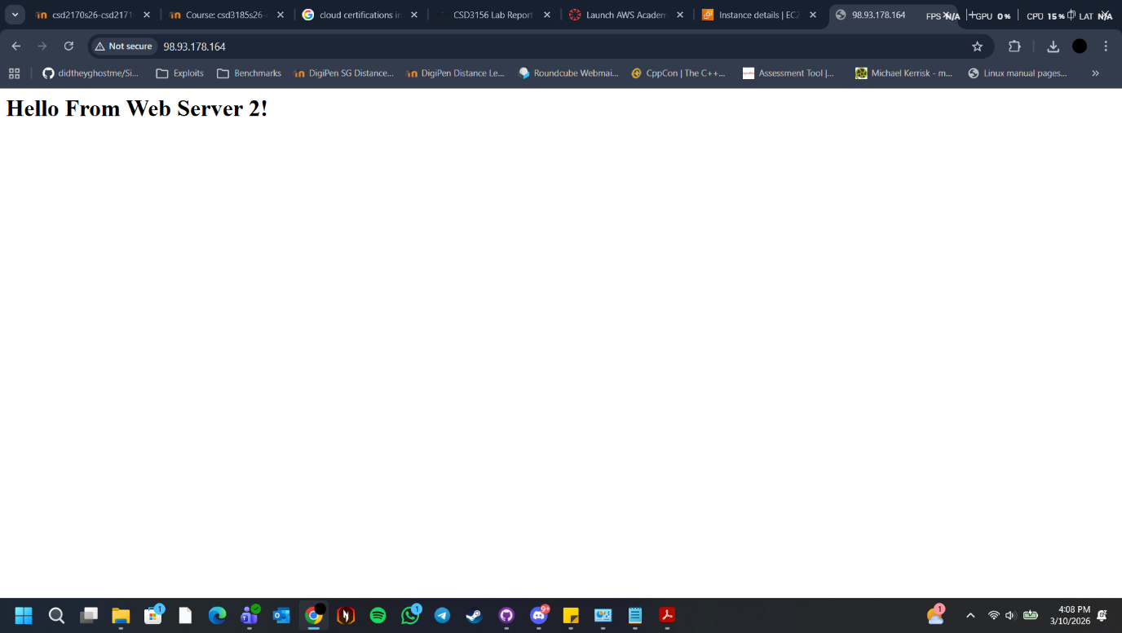
- 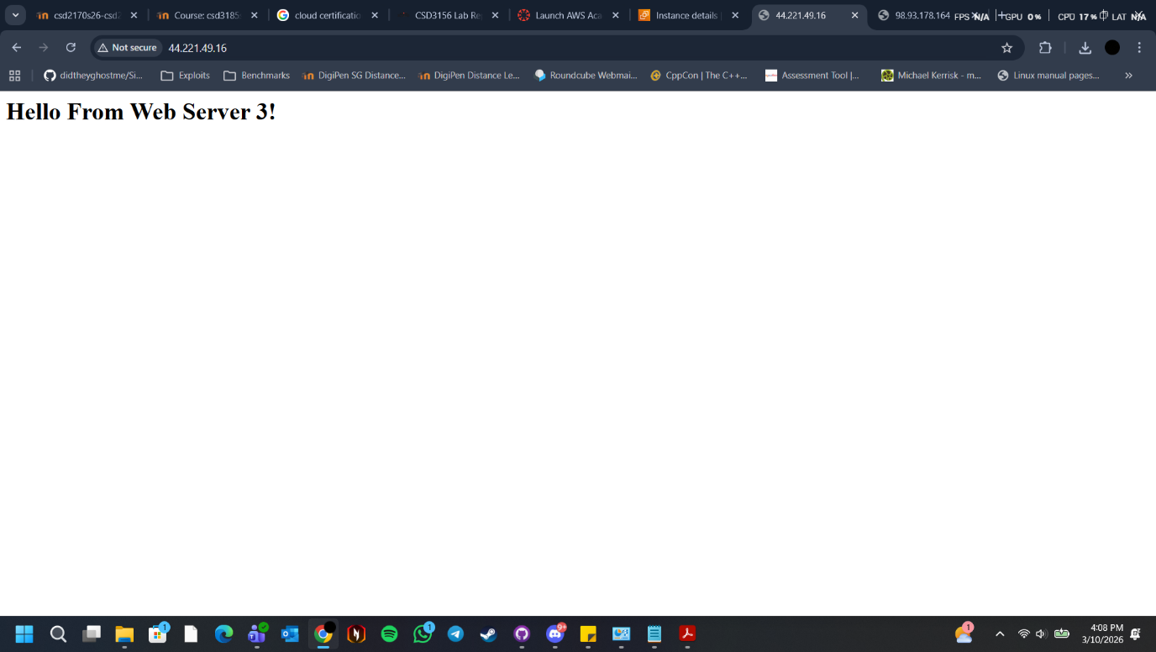

Result 2: Please paste the screenshots in the box below.
1. 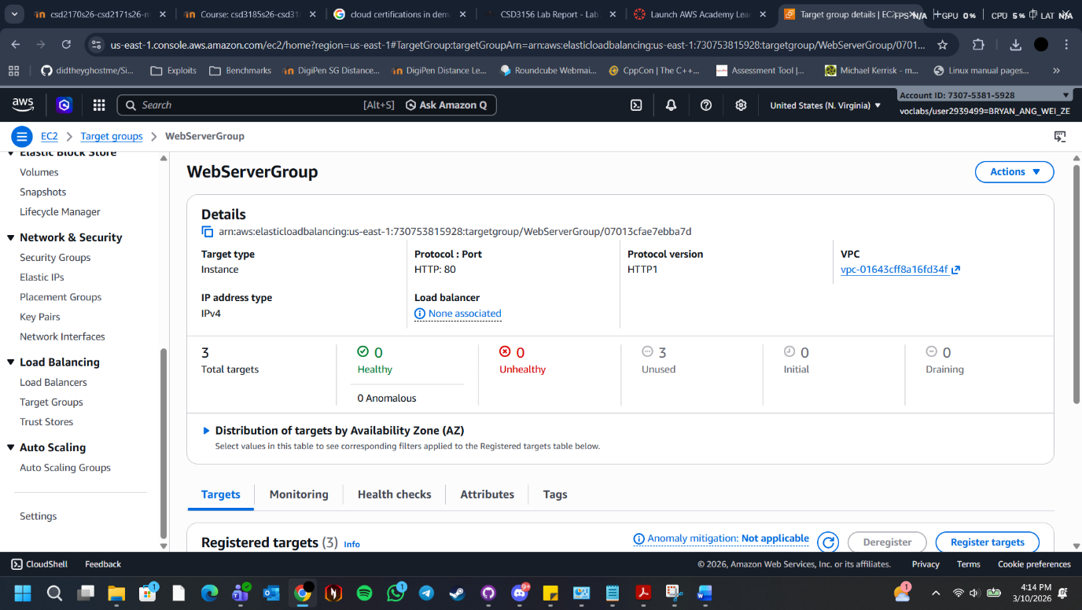
2. 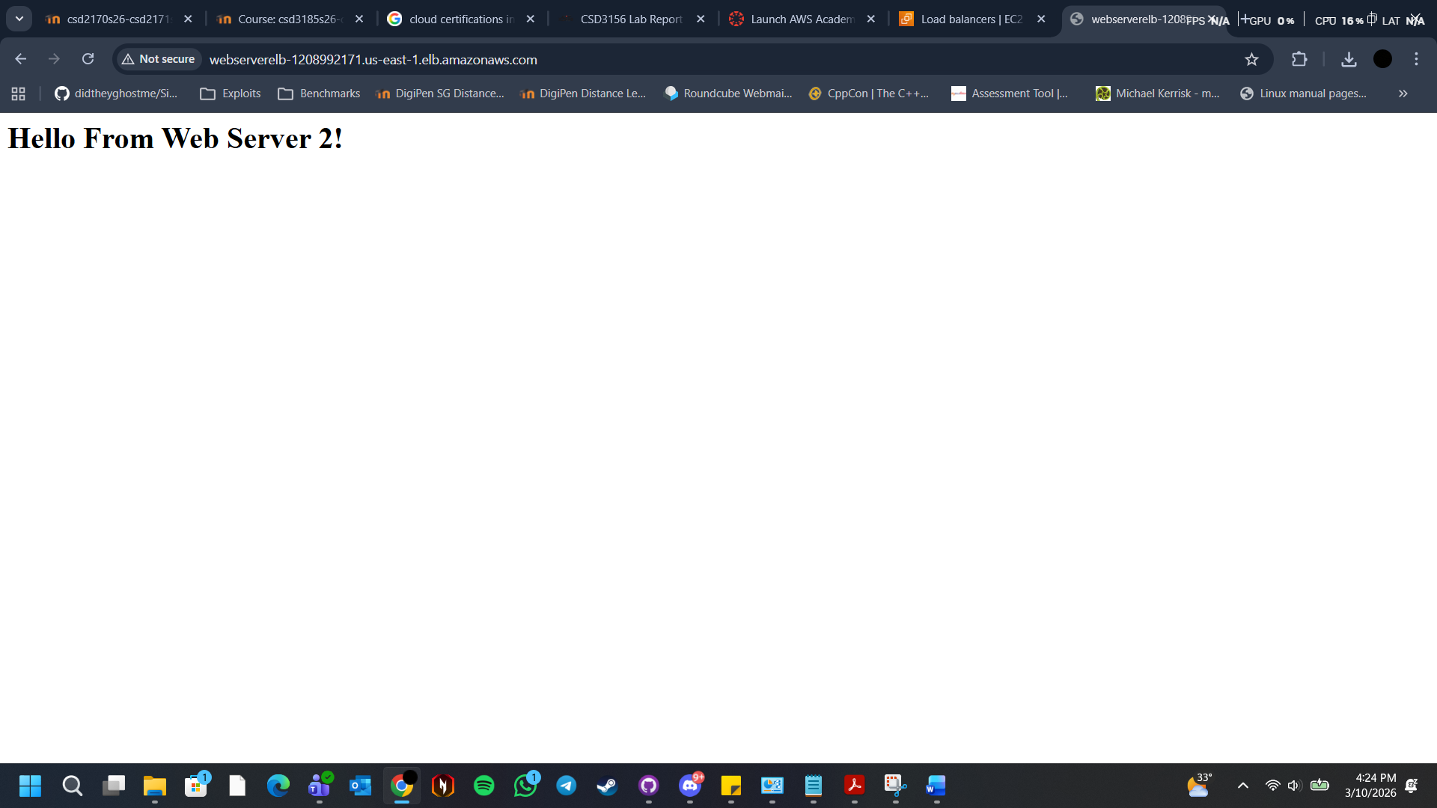

Result 3: Please paste the screenshots in the box below. (Optional)
1. 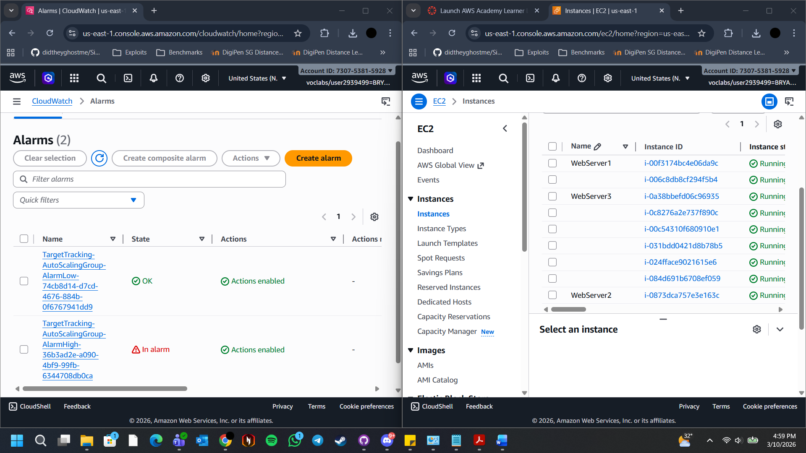
2. 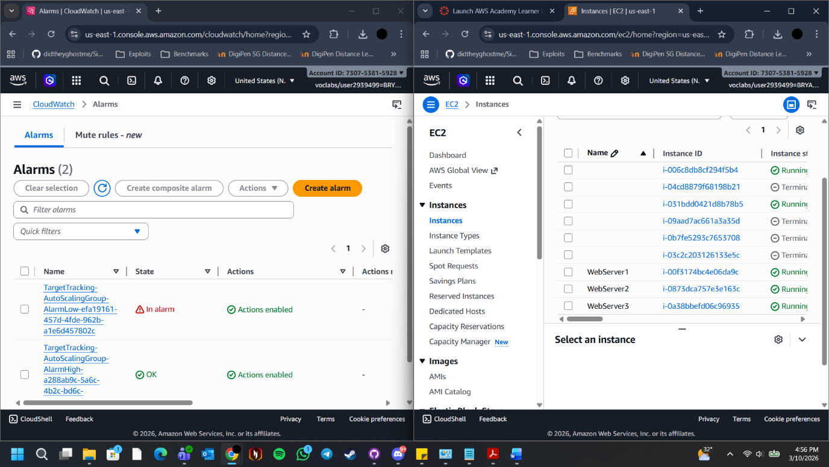

Reflection: Please add one or two lines on what you have learned.
Creating web server image, launching multiple web servers using the image, configuring/creating load balancer, enabling auto scaling for web applications and testing auto scaling.

